The Screening for Novel Exoelectrogenic Microorganisms via Magnetotaxis, Iron Tolerance, and Microbial Fuel Cell Testing

Giovanni Duca
Dr. Linae Boehme
Dr. Ray Menard
12/5/2019

Abstract
Microbial fuel cells are technology that could be another solution to combating climate change while bolstering our ability to produce electricity and revolutionizing our ability to treat wastewater. They’ve been shown to have applications in desalination, bioremediation, and hydrogen production all with the benefit of producing electricity as well. They work on the principle of harnessing a bacteria’s cellular respiration to convert chemical energy into electrical energy, however only certain kinds of bacteria can have their cellular respiration harnessed like this, specifically exoelectrogens. One of the issues that is holding this technology is low amount of exoelectrogens that have been found. In the pursuit of finding more exoelectrogens, this study proposed that new exoelectrogens could be found by screening them for iron tolerance and magnetotaxis. Multiple papers have shown that exoelectrogens can be magnetotatic and have high tolerances to iron. The results of the experiments conducted did not bear this to be true. It is this study’s opinion that the methodology of experiments was flawed and not the general concept that was flawed. More research is needed to full conclude if this concept is flawed.
Introduction
In recent times climate change has become an issue at the forefront of societal consciousness. At the same time global energy demand is projected to increase by 2.1% per year until the year 2040 (IEA 2019). This increasing electrical demand will cause even more greenhouse gas emissions; however, this demand is also spurring on the growth and proliferation of green alternative energy sources. One relatively new and over looked technology for power generation is microbial fuel cells. Microbial fuel cells(MFC) are a subset of bioelectrochemical systems which include anaerobic digestors and hydrogen fuel cells. The novelty of microbial fuel cells is their ability to both break down substrates, such as wastewater, and produce electricity at the same time. This is the driving cause for the great interest seen in microbial fuel cells. Beyond the ability to just produce electricity, MFCs have been shown to be a great jumping off platform for hybrid systems. Systems that combine desalinization, bioremediation, and/or hydrogen production with an MFC have shown to be robust systems that could double the power generation of standalone MFCs (Zhang 2019). A microbial fuel cell uses a bacteria’s ability for cellular respiration to convert chemical energy into electrical energy (Mohan 2018). This is done by spatially separating out the redox reactions of the bacteria’s cellular respiration. This spatial separation forces the electrons produced during the oxidation reaction to flow through a circuit before completing the reduction reactions (Allen 1993). All MFCs have a few key components that influence power generation, and these include the bacteria/consortia being used, the electrodes, and the proton exchange membranes, the setup, and the substrates being used. All of these components have been under constant experimentation to push the electrical output of MFCs. MFCs electrical output is notorious for be very low. New advances in material sciences, specially the development of 2D materials, has possibly opened the door to far more efficient and conductive electrodes (Slate 2019). Other advances towards increasing the electrical output of MFCs is by manipulating the bacteria that are used as well as finding more energetically efficient bacteria. Some methods for manipulating the bacteria are using mixed cultures, chemically modifying their outer membranes, or genetically altering their electron shuttles(Li 2018).
The bacteria used in MFCs are exoelectrogens. Exoelectrogens are microorganisms that have a modified electron transport chain in which the final electron acceptor is outside the cell. Since the electrons must pass outside the cell, many of these microorganisms have modified cytochrome c complex or produce their own electron shuttle proteins (Li 2018). The passage of electrons from the inside of the cells to the outside environment produces an electrical charge which is the basis for how an MFC can produce electricity. Exoelectrogens have been found to be present in nearly all sediments and terrestrial soils and can account for 7% of soil microbiome (Wang 2019). A majority of exoelectrogens are facultative anaerobes and their final electron acceptors are usually Iron(III), manganese, sulfates, phosphates, or nitrates (Li 2018). In fact, many bacteria that are classified as dissimilatory iron-reducing bacteria are also exoelectrogens (Zuo 2008). The ability to reduce iron or another metal is sign of dissimilatory iron-reducing bacteria. Many dissimilatory iron-reducing bacteria can also be magnetostatics (Lovley 1987). Magnetotaxis, sensitivity to magnetic fields, arises from the production of a magnetosome. A magnetosome is an iron-rich magnetic particle encapsulated in lipid-bilayer, the iron-rich magnetic particle is usually magnetite (Delong 1993).
This study’s purpose was to find new exoelectrogenic bacteria. We hypothesize that by screening for iron tolerance and magnetotaxis new exoelectrogenic bacteria can be found and characterized. This hypothesize is built upon the findings of another study that used a magnet to help facilitate the findings of novel electrogenic bacteria(Kiseleva 2015). It is also based on evidence showing that dissimilatory iron-reducing bacteria can produce magnetite(Lovely 1987).

Methods
Marine Sediment Sampling and Preparation
Sediment samples composed of mostly sand were taken from the intercoastal beach of Phillipee Park, Safety Harbor, Florida. The coordinates of the sample site are 28.0113520 N by -82.6803710 E and the sample was taken on September 13th, 2019. The temperature of the sediment was 28ºC. The sample was taken from a water depth of approximately 1 foot and an additional soil depth of approximately 1 foot. It was homogenized in a container before being split and deposited into six culture jars, labeled A-F. Each jar was filled 3/4ths of the way with sediment and topped off with seawater. The jars were brought back to the lab immediately and placed in a 25ºC incubator and left to incubate overnight. A dilute solution of 1 drop methylene blue and 200 ml of water was prepared. Each jar sample was then combined with 50 ml of the dilute methylene blue solution before being blended for 5-10 seconds. The addition of methylene blue solution was to decrease or eliminate the majority of the fungal cells that may be present in the sediment samples. From there three different techniques were used to plate the samples onto media substrates. Two different media were used, a deoxygenated tryptic soy agar(ATSA) and an iron, ferric chloride additive, enhanced thioglycolate agar(Iron THG) which was also deoxygenated. The medias were deoxygenated by flooding them with nitrogen gas right after they came out of the autoclave. The first method filtered the blended solution through a coffee filter and the filtrate, 100 ul, was pipetted onto a plate and spread into a lawn. The second method dipped the bottom of a sterile rubber stopper into the blended sample and which was then used to stamp the plate 6 times in a circular formation. Each stamp leaving less particulates then the last, they’re by serially dilution the sample. The third and final technique was the direct addition of approximately a gram of blended sample to the plate. Each jar sample had six corresponding plates for the three techniques and two media types, each grouping of six plates was then incubated at a different temperature overnight. Those temperatures were as follows: 20ºC,25 ºC,37ºC, and 45ºC. The excess from three of the blended samples was added to a 500ml bottle and was topped off with water. Three magnets were then attached at equidistant points to the outside of the bottle. The bottle was then thoroughly shaken and left to rest at room temperature.
Sedimentary Microbial Fuel Cell Setup & Operation
Using the sediment sample collected in the 500ml bottle a sedimentary microbial fuel cell was setup. The sedimentary microbial fuel cell was a MudWatt Stem kit and its setup up and operation was conducted according to its manufacturer’s instructions. Once the diode on the MudWatt started to emit light an initial reading was taken using the MudWatt app before the electrode wires were connected to a Track-It™ DC Voltage & Current Data Logger sourced from Monarch Instruments. The sedimentary MFC was then allowed to run continuously with data readings being downloaded twice two periods 3-7 days.
Isolating Bacteria
From those 36 plates, the plates that were incubated at 20ºC, 35ºC, and 37ºC were selected for further culturing. Those temperature were selected because of ease of maintaining them and they were close to the ambient temperature of the sediment when it was taken. Approximately five or less novel single bacterial colonies were taken from each of the selected plates and cultured in their corresponding broth medias. From there they were incubated overnight at their respective temperatures, except for the 35ºC which had all of its bacterial strains incubated at 30ºC. The broth cultures were then streaked out, using four quadrant method, onto their respective medias. After overnight incubation, individual colonies were selected for culturing. This process was repeated four times After the fourth round of culturing samples showed to be monocultures were selected for experimentation. It should be noted that after the first plating of samples the medias underwent multiple changes. The tryptic soy agar(TSA) used after the first plating of samples was not deoxygenated nor was iron enhanced thioglycolate(Iron THG) deoxygenated after the first plating. The iron enhanced thioglycolate also underwent changes because of precipitation problems in the broth. Final formula of the iron enhanced thioglycolate switch out the ferric chloride for ferrous sulfate.
Two other bacterial strains were also isolated from different sources then the original sediment samples. One bacteria strain was isolated from a previous experiment in which a magnetic was buried in nutrient agar plate. This bacterium was labeled UMN. This bacterium was cultured at 30ºC and underwent four rounds of culturing until a pure strain could be guaranteed. It was also cultured on three different medias, Iron THG, TSA, and Nutrient Agar in the first round of culturing before solely cultured on TSA. The other bacterial strain originated from the ferrous particulate matter gathered by magnets within the 500ml bottle of seawater and sediment. A sterile knife was used to scrap the ferrous particulate matter from the insides of the bottle. That ferrous particulate matter was then placed into 1.5ml microcentrifuge tubes and the tubes were then filled with 1ml of sterile water. The tubes, three of them, were then spun at 6000rpm for 5 minutes. The supernatant was then pipetted off and more scrapings were added. This process was repeated five times after which the pellets that were formed. The pellets were resuspended with sterile LB broth and vortexed before being plated onto NA and inoculated in Iron THG broth and tryptic soy broth and incubated overnight at 30ºC. The bacteria then underwent four rounds of culturing, utilizing solely TSA media, until a pure monoculture could be guaranteed. This bacterium was labeled MO-C.
Bacteria were isolated from the anode of the sedimentary MFC; however, monoculture was not achieved. Under sterile conditions the anode of the sedimentary MFC was dug out. Using a sterile scalpel, the biofilm and part of the anode, which was composed of carbon cloth, was scraped off and placed into test tubes containing tryptic soy broth. A mineral overlay was then added to the tubes after which the tubes were placed in an anaerobic jar and allowed to incubate at room temperature overnight. After that incubation period, the cultures were then serially diluted up to the 10^-6 power. 10^6 culture was then kept under a mineral overlay within an anaerobic jar and allowed to incubate at room temperature overnight. That sample, labeled 10^-6 Sediment Anode Sample, was then used for Iron Tolerance experiments and Dual-Chamber Microbial Fuel Cell trials.

Magnetotaxis Testing
The magnetotaxis experiments were meant to test for sensitivity to magnetic fields within bacteria. The first trials used bacterial cultures grown on Iron enhanced thioglycolate broths. In the first sterile needle was inoculated with a culture and was then used to draw a straight line across the middle of the plate. A magnet was then attached to one side of the plate parallel to the line of bacteria. 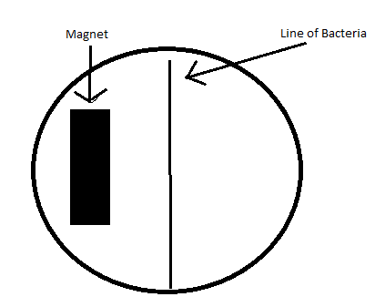
The plate was then incubated overnight at the culture’s corresponding temperature. In the second trials, the A21 was not test, however all other culture samples stayed the same. The media used in the plates was switched out for motility media since it was thought that would help facilitate the movement of the bacteria toward or away from the magnet. In the third trial all of the cultures stayed the same. The plate media also stayed the same. In contrast to previous experiments a different method of inoculating the plate was used. A 10 ul drop of broth containing samples culture was deposited in the center of the plate. A magnet was then placed in a tangent position to the walls of the plate. All previous procedures for incubation were then followed.
Iron Tolerance Testing
The concept of the iron tolerance was to see if the bacteria could tolerate increasing concentrations of iron. To simulate this, various concentrations of ferrous sulfate were added to test tubes containing sterile tryptic soy broth. The stock bacterial samples were then inoculated into the tubes and allowed to incubate at their corresponding temperatures overnight. After this incubation period the cultures were then streaked out onto nutrient agar plate using the four-quadrant method. The cell viability for each iron concentration could then be found. Preliminary tests used ferric chloride, but it was found precipitate out of solution. The Iron tolerance tests were split into two rounds of testing for the following samples: D312, E111, MO-B, and UMN-B. The 10^-6 sediment anode sample had only one round of tests done. The first round of tests for all of the samples except the 10^-6 sediment anode sample used concentrations 0.5%, 1%, and 1.5% ferrous sulfate. All other rounds of tests for all samples including the 10^-6 sediment anode sample were done at concentrations of 1%,2%, and 3% ferrous sulfate. It should be noted that the 10^-6 sediment anode sample had a mineral overlay present during testing.
Dual-Chamber Microbial Fuel Cell Setup and Operation
A dual-chamber microbial fuel cell was setup and operated for multiple runs with the following samples: UMN-B, MO-B, and 10^-6 Sediment Anode sample. The UMN-B and MO-B samples were run only once the Dual-Chamber MFC and the 10^-6 Sediment was run three times. The dual-chamber MFC was built with a square acrylic body with two cylindrical chambers containing two fluid intake/outtake holes which were plugged during operation. Each chamber had a volume of 28ml. The two chambers were divided by a proton exchange membrane, Nafion 212, and two carbon cloth electrodes. The electrodes were connected to the Track-It™ DC Voltage & Current Data Logger via copper wires completing the circuit. The cathode chamber, throughout all tests, contained water. The anode chamber was filled with a 10% Sodium Acetate before it was inoculated with 100 ul of a broth sample culture. Each run lasted for 3-7 days and was operated at room temperature. Voltage readings were taken at 10-minute intervals. The averages for each run for each bacterium were calculated. A t-test was then conducted comparing the averages of each run of the Sedimentary MFC and the 10^-6 Sedimentary Anode Sample run averages.
Results
Table 1- Above is a table displaying the results of the Magnetotaxis Experiments. It shows the results for each unknown bacterial sample and the media used as well as the technique used inoculate the plates.
Testing Media | Method | Trial | Bacteria | Result
Iron THG | Centerline | 1 | UMN-B | Inconclusive
Iron THG | Centerline | 1 | MO-B | Inconclusive
Iron THG | Centerline | 1 | D24 | Inconclusive
Iron THG | Centerline | 1 | A21 | Inconclusive
Iron THG | Centerline | 1 | D312 | Inconclusive
Iron THG | Centerline | 1 | D221 | Inconclusive
Iron THG | Centerline | 1 | E111 | Inconclusive
Motility Media | Centerline | 2 | UMN-B | Inconclusive
Motility Media | Centerline | 2 | MO-B | Inconclusive
Motility Media | Centerline | 2 | D24 | Possible Hit
Motility Media | Centerline | 2 | D312 | Possible Hit
Motility Media | Centerline | 2 | D23 | Possible Hit
Motility Media | Centerline | 2 | E111 | Inconclusive
Motility Media | 10ul Drop | 3 | D312 | Inconclusive
Motility Media | 10ul Drop | 3 | D23 | Inconclusive
Motility Media | 10ul Drop | 3 | MO-B | Inconclusive
Motility Media | 10ul Drop | 3 | UMN-B | Inconclusive
Motility Media | 10ul Drop | 3 | E111 | Inconclusive
.
In Table 1, you can see the how methodology of the experiment changed over time as new insights were found and new approaches were used. This is evidenced by change from Iron THG to Motility Media and the change in inoculation technique from a centerline drawn by needle to a 10ul droplet. The bacterial samples used consistently throughout all three experiments were as follows: UMN-B, MO-B, D24, D312, D23, and E111. The bacterial sample A21 was used only in the first trial. In every single experiment the results were inconclusive, there was no substantial change in bacterial growth pattern whether towards or away from the magnet. All results that are listed as a possible hit are highly tentative and upon further experimentation were shown to be inconclusive.
Table 2- Above is a table displaying the results of Iron Tolerance experiments, specifically showing the cell viability post exposure to ferrous sulfate. It displays the results of the cell viability tests conducted post exposure to various ferrous sulfate concentrations. It also displays the platting media used in the cell viability.
Testing Substrate | Trial |  | Control | 0.50% | 1% | 1.50% | 2% | 3%
Nutrient Agar | 1&2 | D312 | 1 | 1 | 1 | 1 | 1 | 1
Nutrient Agar | 1&2 | E111 | 1 | 1 | 1 | 1 | 1 | 1
Nutrient Agar | 1&2 | MO-B | 1 | 1 | 1 | 1 | 1 | 1
Nutrient Agar | 1&2 | UMN-B | 1 | 1 | 0 | 0 | 0 | 0
TSB/mineral oil overlay | 1 | 10^-6 Sediment Anode Sample | 1 | N/A | 1 | N/A | 0 | 1

Table 2 displays the results of the Iron Tolerance experiments for bacterial samples D312, E111, MO-B, UMN-B, and 10^-6 Sediment Anode Sample. These results show the cell viability of each sample post exposure to increasing ferrous sulfate concentrations. The D312, E111, MO-B, and UMN-B samples underwent two trials. In the first trial these samples were exposed to ferrous sulfate concentrations of 0.5%,1%, and 1.5%. The second trial used concentration of 1%,2%, 3%. The 10^-6 Sediment Anode sample had only one trial with concentrations of 1%, 2%, and 3% ferrous sulfate. It was also grown under within a different media, tryptic soy broth, with a mineral overlay. The 10^-6 Sediment Anode Sample did show notable drop in cell viability at the 2% ferrous sulfate concentration. The UMN-B sample was the only one to show a sensitivity to increasing iron concentrations. Its cell viability died off at concentrations greater than/equal to 1% ferrous sulfate. All other samples seemed to tolerate greater concentrations of iron, ferrous sulfate.

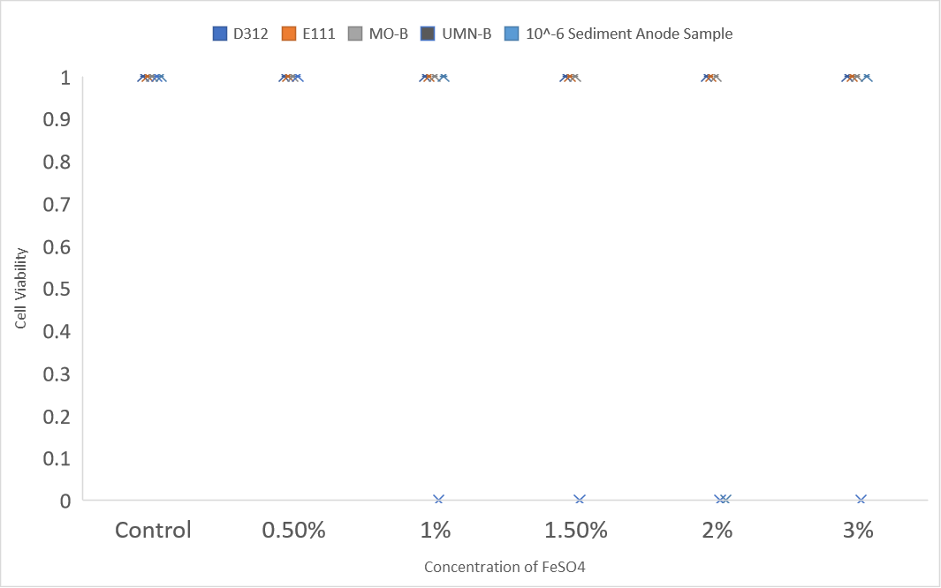
Figure 1- A crosshatch graphical representation of the results of the iron tolerance tests.
The above figure, Figure 1, is a graphical representation of Table 2. The color of each crosshatch marking corresponds to specific bacterial sample. The crosshatches at the zero correspond to no growth observed after exposure to that specific concentration of ferrous sulfate. The crosshatches at the one correspond to growth being observed after exposure to that specific concentration of ferrous sulfate.
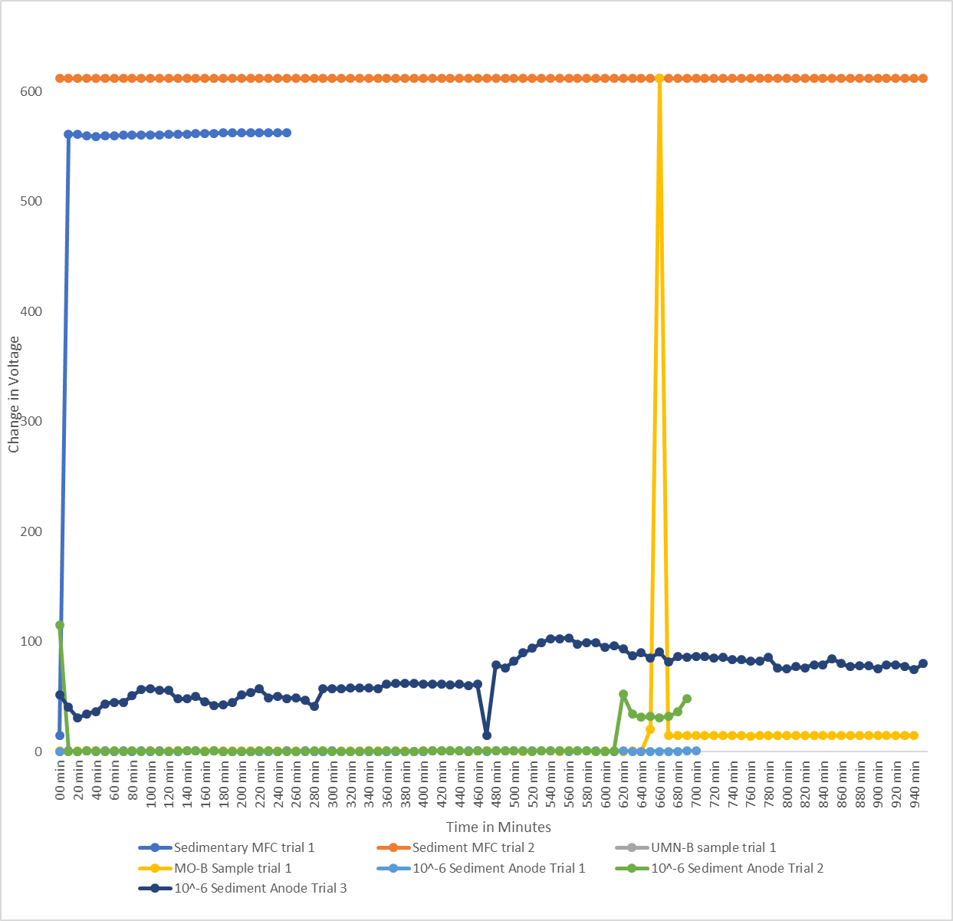
Figure 2- Above is a graph displaying the trial runs for each unknown bacterial sample conducted on the dual chamber microbial fuel. The graph displays the change in voltage over time in 10-minute intervals.
Figure 2 is graphical representation of the change in voltage over time for the bacterial samples tested the Dual-Chamber microbial fuel cell. The results of Sedimentary microbial fuel cell were also included in this graph. Data was collected on two operational runs for the Sedimentary MFC, these runs are represented by orange and light blue lines in Figure 2. The 10^-6 Sedimentary Anode sample had three operational runs in the dual chamber MFC as displayed by the dark navy line, green line, and hidden turquoise line in Figure 2. The first operational run of the 10^-6 Sedimentary Anode sample had voltage readings of below 1 mV. The following runs for the 10^-6 Sedimentary Anode sample showed slow increase in voltage as time went on. The MO-B and UMN-B samples both had only one operational run on the dual chamber MFC. UMN-B sample displayed voltages below 0.7mV. The MO-B sample displayed voltages at below 1mV except for highly anomalous spike of 611mV at the 660-minute mark.

Table 3- The voltage averages used in the T-test Analysis. These voltage averages are derived from the results of the dual-chamber MFC, specifically testing the 10^-6 Sediment Anode sample, and the Sedimentary MFC.
Voltage Averages used in T-test
Sedimentary MFC trial 1 | 540.1692 | 10^-6 Sediment Anode Trial 1 | 0.335211
Sediment MFC trial 2 | 611.6 | 10^-6 Sediment Anode Trial 2 | 6.187143
 |  | 10^-6 Sediment Anode Trial 3 | 68.36771
`
A T-test was administered on the resulting voltage averages of the operational runs for 10^-6 Sediment Anode sample, conducted in the dual chamber MFC, and the operational runs of the Sedimentary MFC. Theses voltage averages are displayed in Table 3.
Table 4- Table 4- Above descriptive results of the t-test comparing the averages of MFC trial runs of the Sedimentary MFC and the MFC trial runs for the 10^-6 Sedimentary Anode Sample.
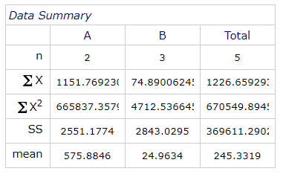
Table 4 shows the descriptive statistics generated from the T-test on the average voltages for the sedimentary MFC and the 10^-6 Sedimentary Anode sample. The variances were unequal. The variables were considered independent.
Table 5- Table 6- The results of the T-test analysis on the voltage averages of the Sedimentary MFC and the 10^-6 Sedimentary Anode MFC.
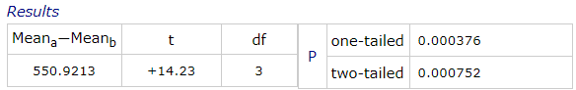
In Table 5, the final result of the T-test on the average voltages for the Sedimentary MFC and the 10^-6 Sedimentary Anode Sample are displayed. The degrees of freedom were 3.This was a two-tailed T-test and its p-value was found to be 0.000752. Thus, the null hypothesis is rejected which indicates that the results in this particular case are significant. This meant that the voltage output for the Sedimentary MFC and the 10^-6 Sedimentary Anode Sample cannot be simply attributed to chance or background noise. It should be noted though that since this T-test used averages for its inputs, the power of the test was dramatically decreased and the fact that it only had five values inputted into it also further decreased its power.
Discussion
This study started out with the goal of finding novel exoelectrogenic bacteria. In that regard this study was successful. Figure 2 shows that exoelectrogenic bacteria were present in the marine sediment samples as evidenced by the voltage readings of the sedimentary microbial fuel cell. The extraction of the biofilm layer from the anode of the sedimentary MFC and subsequent culturing and then testing of that sample, labeled 10^-6 Sediment Anode sample, in the dual chamber MFC shows that novel exoelectrogenic bacteria were found. The T-test that was performed on the voltage readings of the sedimentary MFC and 10^-6 Sediment Anode sample showed that the voltages on their own were significant and not due to background or pure change. It should be noted though that the power of that T-test was greatly diminished since it used the averages of the data sets instead of the raw values themselves. It should also be noted that the sedimentary MFC was only run twice and 10^-6 Sediment Anode sample was run 3 times on the dual chamber MFC. Pure cultures and full characterizations of 10^-6 Sedimentary Anode sample were unable to be obtained because of time constraints. The results of the dual chamber MFC should be considered under suspicion. At least two times during two separate runs the lead wire connecting to the anode in the MFC was found to be totally corroded off and disconnected from the system. This puts nearly all of the results under suspicion. The corrosion was likely due to the composition of wire, iron-nickel. Those lead wires should’ve been switched out for titanium wires, which have been used in similar conditions in other studies and do not have any corrosion problems(Kiseleva 2015).
The initial process that was used to isolate bacteria from the marine sediment sample was not the most suitable for finding exoelectrogenic bacteria. This was shown to be true by extremely low voltage readings of the UMN-B and MO-B samples, Figure 2, which were both isolated from the sediment sample and not from the anode biofilm of the sedimentary MFC. The reason for why the initial bacteria isolation process was so poor of a selector for exoelectrogenic bacteria is likely because it was not conducted under anaerobic conditions consistently. The exoelectrogenic bacteria are facultative and obligate anaerobes(Allen 1993). This is likely why so few exoelectrogens were found.
However, the idea of using magnetotaxis and iron tolerance as screens to help find exoelectrogenic bacteria ultimately failed. This study suffered from multiple problems and the most prominent problem was the lack of replication during each trial of each experiment. Though experiments were repeated with the same set of bacterial samples, refer to Tables 1 & 2, there was no replication within each trial.
The magnetotaxis experiments were shown to be inclusive, refer to Table 1. Every single sample was found to show no movement either towards or away from the magnet. This was likely due to the testing methodology being flawed and the bacterial isolation process being unideal for finding magnetotatic bacteria. The methodology of placing a magnet on one side of the petri dish and allowing the bacteria grow was likely flawed because the magnet was likely not strong enough to influence the bacterial growth. A better method for finding magnetotactic bacteria would’ve been to use a method called the capillary racetrack which would’ve separated the magnetotatic bacteria from the nonmagnetotactic bacteria(Kiseleva 2015). Another change that would’ve increased the odds of finding magnetotatic bacteria would’ve been culturing everything under anaerobic conditions.
The iron tolerance tests were based around the idea that since most exoelectrogens use iron as their final electron acceptor then their tolerance for that element should be relatively high (Zuo 2008). In Table 2 and Figure 1, it can be seen that nearly all of the bacterial cultures showed cell viability after being exposed to increasing amounts of iron. However, these results are likely not accurate since these iron tolerance experiments were plagued by problems with the iron additive. In every single experiment the ferrous sulfate that was added to the broth would precipitate out of solution and form a floating layer of solid atop the broth. This likely means that the actual dissolved iron that the bacteria were exposed to were likely significantly lower than what was reported. Also, a far better idea for screening for exoelectrogenic bacteria would’ve been to see how much iron was reduced and not simply how much could be tolerated.
This study had the simple goal of finding novel exoelectrogenic bacteria. In a limited capacity it did accomplish this however it was not able to show that magnetotaxis and iron tolerance could be used as filters for finding exoelectrogenic bacteria. That is not because the concept itself was flawed but that the methodology and execution were not correct. With the new insights generated from this study, it is my opinion that more novel exoelectrogenic bacteria could be found using the three-pronged approach of magnetotaxis, iron tolerance, and microbial fuel cell testing.

References
Allen RM. & Bennetto HP. 1993. Microbial Fuel-Cells Electrons Oxidation Mediator Reduced, Oxidant
Fuel, Reduced Oxidant Ion-exchange. Applied Biochemistry and Biotechnology. 39

DeLong, E. F., Frankel, R. B., & Bazylinski, D. A. 1993. Multiple Evolutionary Origins of Magnetotaxis in
Bacteria. Science. 259(5096); 803–806. doi:10.1126/science.259.5096.803

IEA. 2019. World Energy Outlook 2019. IEA, Paris https://www.iea.org/reports/world-energy-outlook-
2019

Kiseleva, L., Briliute, J., Khilyas, I. V., Simpson, D. J. W., Fedorovich, V., Cohen, M., & Goryanin, I. 2015.
Magnet-Facilitated Selection of Electrogenic Bacteria from Marine Sediment. BioMed Research International. 1–7. doi:10.1155/2015/582471

Li, M., Zhou, M., Tian, X., Tan, C., McDaniel, C. T., Hassett, D. J., & Gu, T. 2018. Microbial fuel cell (MFC)
power performance improvement through enhanced microbial electrogenicity. Biotechnology Advances. 36(4); 1316–1327. doi:10.1016/j.biotechadv.2018.04.010

Lovley, D. R., Stolz, J. F., Nord, G. L., & Phillips, E. J. P. 1987. Anaerobic production of magnetite by a
dissimilatory iron-reducing microorganism. Nature. 330(6145); 252–254. doi:10.1038/330252a0

Mohan SV, Pandey A, Varjani S. 2018. Microbial electrochemical technology: sustainable platform for
fuels, chemicals and remediation. Amsterdam(Netherlands): Elsevier

Slate, A. J., Whitehead, K. A., Brownson, D. A. C., & Banks, C. E. 2019. Microbial fuel cells: An overview
of current technology. Renewable and Sustainable Energy Reviews. 101; 60–81. doi:10.1016/j.rser.2018.09.044

Wang, J., Deng, H., Wu, S.-S., Deng, Y.-C., Liu, L., Han, C., Zhong, W.-H. 2019. Assessment of abundance
and diversity of exoelectrogenic bacteria in soil under different land use types. CATENA. 172; 572–580. doi:10.1016/j.catena.2018.09.028

Zhang, Y., Liu, M., Zhou, M., Yang, H., Liang, L., & Gu, T. 2019. Microbial fuel cell hybrid systems for
wastewater treatment and bioenergy production: Synergistic effects, mechanisms and challenges. Renewable and Sustainable Energy Reviews. 103; 13–29. doi:10.1016/j.rser.2018.12.027

Zuo, Y., Xing, D., Regan, J. M., & Logan, B. E. 2008. Isolation of the Exoelectrogenic Bacterium
Ochrobactrum anthropi YZ-1 by Using a U-Tube Microbial Fuel Cell. Applied and Environmental Microbiology. 74(10); 3130–3137. doi:10.1128/aem.02732-07

